If else
- Write a program to find the smallest number among two given integers.
- Write a program to find the largest number among two given integers.
- Write a program to find the absolute value of a given integer.
- Check if a given number is even number or odd number
- Determine whether the given number is a multiple of 5 or not.
- Determine whether the given number is a multiple of 10 or not.
- Check whether the given number is a two-digit number or not.
- Check whether the given number is a three-digit number or not.
- Check if a given number ends with zero or not.
- Write a program to accept a number and check if its square is above 50 or below 50.
- Write a program to accept two numbers, subtract the two numbers and check if the difference (answer) is 0 or not
- Write a program to read the Computer Science marks of a student and print if the student has passed or failed. The student has passed if marks is 50 or above otherwise failed).
- Write a program to accept a number and check if the number is divisible by 10.
- Write a program to take a two-digit number and print the biggest digit.
- Write a program to accept the choice from the user. If the choice is 1 print “The exam will be easy”, otherwise print “The exam will be difficult”.
- Write a program to accept a value from the user. If the value entered is 1 then print “You can go out and play” otherwise “You cannot go out and play”
- Write a program to accept the length and breadth of a shape and print if they are the same. If they are the same, print it’s a square otherwise its rectangle.

- Check if a given number is the ASCII value of an uppercase alphabet or not.
- Check if a given number is the ASCII value of a lowercase alphabet.
- Check if a given number is the ASCII value of a numeric character or not.
- Check whether the given number is a multiple of both 5 and 3.
- Check if a given number is a three-digit number and also a multiple of 10.
- Check if a given number is a three-digit number and also a multiple of 2, 5, and 10.
- Check the given two integer inputs. If both numbers are even, find their product. Otherwise, find their sum.
- A number is said to be Buzz Number if it ends with 7 or is divisible by 7. Example: 1007 is a Buzz Number. Define a class Buzz number to read a number and check if it is a Buzz number or not.

If elif else

- Find the largest number among three integers.
- Find the smallest number among three integers.
- Check if a given number is greater than 0, if yes then print 'Positive'. If the given number is lesser than 0, then print 'Negative'. If the given number is exactly equal to 0, then print 'Zero'.
- A library charges fine for books returned late. To calculate the fine, define a class Library with the following .To input the number of days books were returned late. To calculate and print the fine based on the following condition:
  - First five days 40 paisa per day
  - Six to ten days 65 paisa per day
  - above 10 days 80 paisa per day
- Write a program that functions as a basic calculator. The program will prompt the user to input two numbers and a mathematical operation (+, -, x, /). It will then perform the selected operation and display the result on the screen.
- Check whether the given number is a multiple of 5, 3, and 7.
- To input weight of the parcel and type of booking (`O' for ordinary and 'E' for express).To compute and display the charges based on the weight of the parcel as per the tariff given
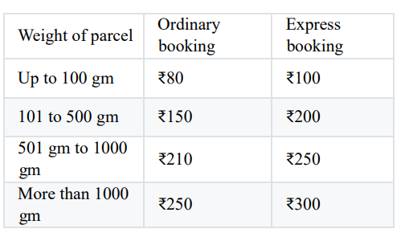
- Write a program to compute the discount according to the given conditions for the purchase of laptop. to take the price of the laptop.to calculate the charge according to the following condition.
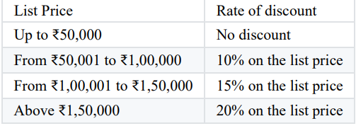
Display the output as per the given format:
Price of laptop :
Discount :
Total Price :

